

An-Najah National University

Factuality of Engineering

Computer Engineering department

Software Engineering (10636312)

Happy Grade

**JDI Group**

**Instructor’s Name :** Shatha Ajaj

**Lecture meeting :(** 12 :30-2 :00)

# ***Table of Contents***

[*Table of Contents* 2](#_Toc89881594)

[*Group member & activity* 3](#_Toc89881595)

[*Calender* 4](#_Toc89881596)

[Add assessment page: 13](#_Toc89881597)

[***Interview with Customer*** 15](#_Toc89881598)

[*User Stories* 16](#_Toc89881599)

[*UML for Project* 17](#_Toc89881600)

[*PRODUCT BACKLOG* 18](#_Toc89881601)

[*Get Hub link* 21](#_Toc89881602)

[*Trello Link* 22](#_Toc89881603)

# 

# ***Group member & activity***

|  |  |  |
| --- | --- | --- |
| **Name** | **ID** | **% worke** |
| Mohee Qwareeq | 11821353 | 100/6 |
| Hadi Nassar | 11820612 | 100/6 |
| Ameer Yaish | 11819809 | 100/6 |
| Mohammad Zaied | 11924576 | 100/6 |
| Nasser Khaled | 11819303 | 100/6 |
| Abd Al-kareem Salah | 11819572 | 100/6 |

## 

## *Calender*

|  |  |
| --- | --- |
| **Metting Date** | **Documentation** |
| **6/Oct/2021** | * In a lecture on Tuesday, we chose group from 6 members and created a messenger group to organize appointments and to facilitate communication. * We wrote **17 User Stories** for the system. |
| **10/Oct/2021** | * In a lecture on Sunday, the team decided Scrum Master the student **Amir Yaish** . * And we decided to call the team GDI, which is an abbreviation for ( just do it). * **We met with customer.** |
| **15/Oct/2021** | * We made a Zoom metting and we distribut the work into team member as this table :  |  |  |  | | --- | --- | --- | | **Name** | **ID** | **Position** | | Ameer Yaish | 11819809 | *Scrum Master* | | Mohee Qwareeq | 11821353 | *Documentation* | | Mohammad Zaied | 11924576 | *Documentation* | | Nasser Khaled | 11819303 | *Programing* | | Abd Al-kareem Salah | 11819572 | *Programing* | | Hadi Nassar | 11820612 | *Programing* | |
| **17/Oct/2021** | * Here the soties we start with :  1. *As a student I want to login.* 2. *As a prof I want to login.* 3. *As a TAs I want to login.* 4. *As a student I want to edit my account information.*   *5- As a prof I want to edit my information.*  *6- As a TAs I want to edit my information.*   * We identified an open source product name: Bees Gate |

|  |  |
| --- | --- |
| **24/Oct/2021** | **Sprint 1**  We Start front-end for our system as picture below :    ***Sign in page***    ***Page for edit information for all user*** |
| **28/Oct/2021** | * We finished coding for the first sprint now we have a database and any user for the system can sign in his profile and edit his information like photos below :     **Page for TA’s**    **Page for professors**    **Page for student** |

|  |  |
| --- | --- |
| **Metting Date** | **Documentation** |
| **5/Nov/2021** | **Sprint 2**   * We start on **sprint 2** which contain this user stories:   *1-As a student, I need to be able to see registered courses,*  *2-As a student, I need to be able to see the instructor's name of my courses*  *3-As a student, I need to be able to see a description for my registered courses*  *4-As a professor or a Teacher Assistant I need to be able to see my courses*  *5-As a Teacher Assistant or a professor, I need to see the students which enrolled in the course*   * Online zoom meeting we divided the tasks of programing. |
| **10/Nov/2021** | * We Start on Teacher page which contain 4 main component   *1-View Modules .*  *2-View Assessment .*  *3- View Marking schema .*  *4- View students.* |

|  |  |
| --- | --- |
| **15/Nov/2021** | * We finished **Teacher’s Page** and below picture for each Subpages |

|  |  |
| --- | --- |
| **18/Nov/2021** | * We Start **Professor’s Page** and below main page picture. |
| **23/Nov/2021** |  |

|  |  |
| --- | --- |
| **Metting Date** | **Documentation** |
| **28/Nov/2021** | * We **finish the second sprint** and finish all subpage for professors   And below there a photo: |

|  |  |
| --- | --- |
| **Metting Date** | **Documentation** |
| **29/Nov/2021** | **Sprint 3**   * We start on **sprint 3** which contain this user stories:   *1-As a Professor, I need to be able to add assignments for students*  *2-As a professor, I need to be able to Add grades for assignments.*  *3-As a student, I need to be able to see my grades only in assignments.*  *4-As a professor, I need to be able to edit the grade of assignments.*  *5-As a Teacher Assistant, I need to be able to write feedback about assignment for each student.* |
| **1/Dec/2021** | * We Start on **student page** and below main page picture. |

|  |  |
| --- | --- |
| **3/Dec/2021** | * We finish **add mark page** And below there a picture:   **Add mark page:** |
|  | C:\Users\moham\Desktop\javascript__shopping__cart-master\New folder\sprint3\13.png  This page can access from prof and TAs , page contains fields that must be fill in to add the mark to the student :   * Module code & name : select code & name of module. * Student id : select id of student. * Assessment : select name of Assessment . * Mark : add student’s mark. * Engagement : select student’s rating. * Feedback : prof write notes to students’. * After fill all field click (add mark) to add student’s mark. |

|  |  |
| --- | --- |
| **4/Dec/2021** | * We finishAdd assessment page and **finish the third sprint** And below there a picture:  **Add assessment page:** |
|  | C:\Users\moham\Desktop\javascript__shopping__cart-master\New folder\sprint3\12.png  C:\Users\moham\Desktop\javascript__shopping__cart-master\New folder\sprint3\12 part2.png  This page can access from prof only, page contains fields that must be filled in to add assessment to the student :   * Module code: fill code of module. * Module name: fill name of module. * Assessment name: put name of assessment. * Assessment deadline: choice end date of assessment. * Assessment weight: put weight of assessment. * Number of mark : Put the rating mark from the total module. * Assessment description : write description of the assessment. * Lecture who can mark this assessment : write name of TAs who can add mark to student’s. |

|  |  |
| --- | --- |
| **Metting Date** | **Documentation** |
| **8/Dec/2021** | We add some modifications that customer requested for  massage and comments |

### ***Interview with Customer***

**First interview (6/10/2021)**

• The customer requested that there be a record show all modifications to the mark and be visible to the professor.

• The customer requested that there be messages between the students and the professor and be public.

• The customer requested that the color coordination be like the Model site of An-Najah University.

Questions:

1- Is the TAs able to view the record of mark modifications?

A: No, just the professor able to show modifications.

2- Is there a conversation between teacher and student where the assignment is delivered?

A: No, There will be a general conversation between the students and the professor.

**Second interview (1/12/2021)**

The customer like the product and add another details and request to delete sum button and replace which we use as a feedback for us .

# ***User Stories***

* As a ***student*** I want to login.
* As a ***student*** I want to interact with my courses.
* As a ***student*** I want to see my grades.
* As a ***student*** I want to edit my account information.
* As a ***student*** I want to submit my assignment.
* As a ***student*** I want to remove the submission before the deadline.
* As a ***prof*** I want to login.
* As a ***prof*** I want to get access to the student’s rosters.
* As a ***prof*** I want to add and edit the grades for each student in order to show them to the student’s.
* As a ***prof*** I want to add an assignment.
* As a ***prof*** I want to remove an assignment only when no grades have been entered for it.
* As a ***prof*** I want to edit my information.
* As a ***TAs*** I want to login.
* As a ***TAs*** I want to see my courses.
* As a ***TAs*** I want to get access to the student’s roster.
* As a ***TAs*** I want to enter and modify grades for each student.
* As a ***TAs*** I want to edit my information

# ***UML for Project***

We bild initial Uml for the product and we will make sum update in near future

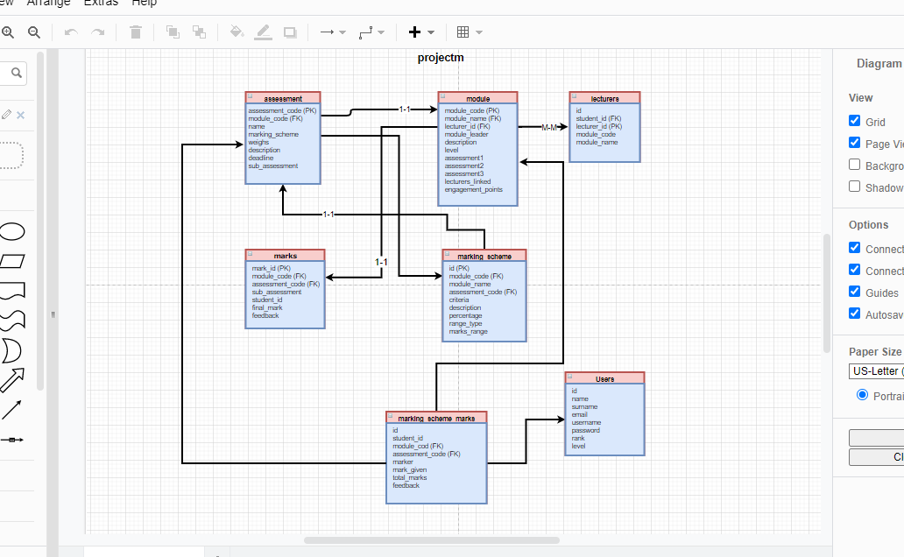

# ***PRODUCT BACKLOG***

**Backlogs Tasks**

I divided this project into ten backlogs, these backlogs are:

* **B1: Authentication Backlog**, it contains tasks: ***T1,T2***
* **B2: Courses Backlog**, it contains tasks: ***T8,T3***
* **B3: Contact Backlog:** it contains tasks:***. T6,T7***
* **B4: Assignments Backlog**: it contains tasks:***.T16***
* **B5: ADD Backlog**: it contains tasks:***.T10,T15***
* **B6: Remove Backlog**: it contains tasks:***.T11,T14***
* **B7: Submission Backlog**: it contains tasks:***.T12***
* **B8: Edit Backlog**: it contains tasks:***.T17***
* **B9: Demo Backlog**: it contains tasks:***.,T4,T9***
* **B10: Feedback Backlog**: it contains tasks:***.T5,T13,T18***

|  |  |  |  |
| --- | --- | --- | --- |
| Backlog  ID | Backlog | Backlogs Tasks | Sprint  Number |
| B1 | **Authentication** | T1+T2 | 1 |
| B2 | **Courses** | ***T8+T3*** |  |
| B3 | **Contact** | ***T6+T7*** |  |
| B4 | **Assignments** | ***T16*** |  |
| B5 | **ADD** | ***T10+T15*** |  |
| B6 | **Remove** | ***T11+T14*** |  |
| B7 | **Submission** | ***T12*** |  |
| B8 | **Edit** | ***T17*** |  |
| B9 | **Demo** | ***T4+T9*** |  |
| B10 | **Feedback** | ***T5+T13+T18*** |  |

**Sprints List**

|  |  |  |  |  |
| --- | --- | --- | --- | --- |
| ID | Sprint Number | Start-Date | End-Date | Duration  (Days) |
| 1 | S1 | Friday, October 15, 2021 | Wednesday, October 20, 2021 | 5 |
| 2 | S2 | **5/Nov/2021** | **28/Nov/2021** |  |
| 3 | S3 | **29/Nov/2021** | **5/Dec/2021** |  |

Task List ***(user may be student or professor or TA)***

|  |  |  |  |
| --- | --- | --- | --- |
| Priority | Task  ID | Backlog Task | Sprint  Number |
| 1 | T1 | As a user, I need to be able to log in into the “Grade Happy” using a registration number, and my  password. | 1 |
| 2 | T2 | As a user, I need to be able to change my password if I forget it | 1 |
| 3 | T3 | As a student, I need to be able to see registered courses, | 2 |
| 4 | T4 | As a student, I need to be able to see the instructor's name of my  courses | 2 |
| 5 | T5 | As a student, I need to be able to  see a description for my registered  courses | 2 |
| 6 | T6 | As a student, I need to be able to contact with my professor | 2 |
|  | T7 | As a Teacher Assistant, I need to be able to contact with the professor | 2 |
| 7 | T8 | As a professor or a Teacher Assistant I need to be able to see my courses | 2 |
| 8 | T9 | As a Teacher Assistant or a professor, I need to see the students which  enrolled in the course | 2 |
| 9 | T10 | As a Professor, I need to be able to add assignments for students  . | 3 |
|  | T11 | As a Professor, I need to be able to remove assignments for students, unless no grades have been entered for them | 3 |
| 11 | T12 | As a student, I need to be able to add a solution for the assignment before the deadline | 3 |
| 12 | T13 | As a student, I need to be able to write a comment about assignment | 3 |
| 13 | T14 | As a student, I need to be able to remove the submission before the deadline | 3 |
| 14 | T15 | As a professor, I need to be able to  Add grades for assignments | 3 |
| 15 | T16 | As a student, I need to be able to  see my grades only in assignments | 3 |
| 16 | T17 | As a professor, I need to be able to  edit the grade of assignments | 3 |
| 17 | T18 | As a Teacher Assistant, I need to  be able to write feedback about  assignment for each student | 3 |

# ***Get Hub link***

<https://github.com/Ameer-yaish/Happy-Grades>

# ***Trello Link***

<https://trello.com/b/sjvuiFG0/happy-grade>